Instructions for Preparing

Fall 2013 Savings Plan Submissions



Department of Planning and Budget
October 2013

TABLE OF CONTENTS
Savings Plan Overview 3
About the Savings Plan Submission 3
Things to Consider 3
Budget Savings Strategy Module Instructions 5
Budget Savings Module Quick Guides 5
Overview Tab Overview 6
Overview Tab Instructions 6
Savings Tab Overview 9
Savings Tab Instructions 9
Narratives Tab Overview 11
Narratives Tab Instructions 11
Budget Savings Bulk Submit Instructions 12
Bulk Submit Overview 12
Bulk Submit Instructions 12

Savings Plan Overview

About the Savings Plan Submission
This package provides guidance and instructions for the submission of savings strategies due to DPB by October 21, 2013.
Your agency must submit plans for FY 2014 that equal two (2) percent of your 2014 appropriation less exempted amounts and four percent of FY 2015 and FY 2016 base budget amounts less specified exemptions.
You will be using the Budget Savings Strategy module and the Budget Savings Bulk Submit to DPB module in the Performance Budgeting System to complete this submission. These modules can be found on the “Operating Budget” menu on the Performance Budgeting system work tray/main screen under the “Budget Savings” submenu. Detailed instructions on the use of the Performance Budgeting system modules are included at the end of this package.
Please note: The data entry mode on the “Savings” tab of the Budget Saving module will default to the “Summary” view initially. You should change this to the “Detail” view. For more info see the detailed instructions at the end of this package.
Your agency’s savings targets are available in the Performance Budgeting System via the “BD5.50 - Savings Strategy Targets” report or within the Budget Savings Strategy module. Contact your budget analyst about any questions you may have about exempted amounts.
Things to Consider
In developing these reduction plans, please take the following into account:
- Focus on new ideas. To the extent you have submitted a savings strategy in a prior year of this Administration and it has not been accepted, please do not resubmit it.
- Focus on low priority activities. Savings plans should focus on identifying the lowest priority activities in your respective agency, rather than on simply eliminating personnel.
- Avoid one-time savings. The emphasis is to take actions that would provide ongoing long-term reductions, rather than one-time savings. Proposals for one-time actions will be considered, but you should limit the use of such proposals to the bare minimum. It may be necessary for you to propose one-time saving in order to meet your FY 2014 target, however, strategies proposed for FY 2015 and FY 2016 biennium should consist predominantly of ongoing savings.
- You may have to include costs to achieve savings. It is permissible for an agency to propose in its budget reduction plan individual strategies that include up-front costs to achieve long-time savings. However, your overall savings plan must show a net savings from all strategies that meet the required savings target for each year.
- Focus on overall savings to the state. You cannot count savings actions that will reduce payments to other state agencies or have a negative financial impact on other state programs. This does not result in overall savings to the Commonwealth. However, we are very interested in any ideas you may have that could reduce statewide costs, so please communicate these to your budget analyst and cabinet secretary.
- Remember that layoffs generate costs. Saving strategies requiring layoffs of personnel may generate costs due to the severance and retirement benefits required under the Workforce Transition Act of 1995 (WTA), as well as the payment of any leave balances for which employees may be eligible.
For more information on state personnel policies with respect to layoffs and furloughs, see the Department of Human Resource Management (DHRM) website for the following policies:
    - Policy 1.30 – Layoff
    - Policy 1.57 - Severance Benefits
    - Policy 1.65 - Temporary Workforce Reduction
    - These policies and other information about layoffs can be found at the following web address: http://www.dhrm.virginia.gov/layoffinfo.html

Budget Savings Strategy Module Instructions
Performance Budgeting System

The Budget Savings Strategy module provides agencies a venue to propose budget savings strategies at the direction of the Governor or the Department of Planning and Budget (DPB). In addition to this documentation, DPB may issue policy guidance as needed to formulate these strategies.

If you have any questions of a policy nature, please contact your DPB budget analyst. If you experience technical issues with the Performance Budgeting System, please contact the VCCC help desk at vccc@vita.virginia.gov (make sure to indicate in the subject line that you are experiencing a Performance Budgeting system issue so that the ticket can be routed to the Performance Budgeting System help desk).
Budget Savings Module Quick Guides

AGENCY ANALYST QUICK GUIDE
- Mouse over the Operating Budget menu item and select Budget Savings Strategy from the resulting menu. Once Budget Savings Strategy is selected, the Overview tab will appear.
- Complete the Overview tab as described in the Overview Tab instructions below.
- Complete the Savings tab as described in the Savings Tab instructions below.
- Complete the Narratives tab as described in the Narratives Tab instructions below.
- Click Submit and select the appropriate action from the available options.
  - Continue Working – Saves the budget savings strategy and returns it to the Available Work Items tab on the Work Tray to be claimed by users with similar credentials.
  - Submit for Agency Review – Submits the budget savings strategy to the next step in the workflow.
  - Void Document – Voids the budget savings strategy.

Overview Tab

Overview Tab Overview
The purpose of the Overview tab is to capture the identifying information for the budget savings strategy.

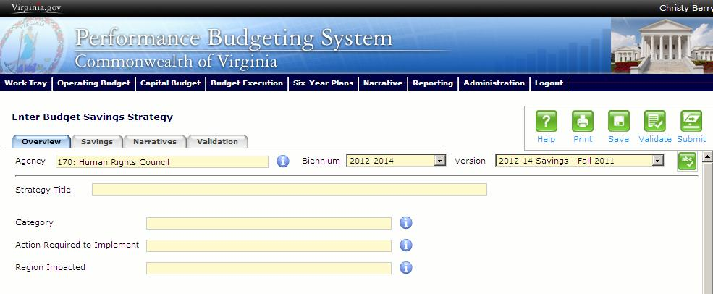
Overview Tab Instructions
- Select the Overview tab.
- Select the Agency to which the budget savings strategy will be applied.
- Select the Biennium to which the budget savings strategy will be applied.
- Select the Version for the budget savings strategy.
- In any given budget savings scenario there may be several different versions/rounds, make sure to verify you are using the correct version.
- Enter the Strategy Title for the budget savings strategy.
Insert a short, descriptive title. Remember that your title should begin with a verb such as "increase," "add," "reduce," "transfer," "shift," "expand," etc.

- Select the Category for the budget savings strategy.
- Reduce personnel costs. This category is for reduction strategies involving personnel that do not involve a reduction in current services. (For strategies that involve a reduction in current service that also include personnel actions, use the "Reduce or eliminate current services" category." Examples include eliminating or reducing contract or wage employees, employee lay-offs, job sharing, or bringing in a new employee at a lower salary (band) than a former incumbent. Keep in mind that turnover and vacancy savings are typically one-time. Savings in this category should take into account salaries and fringe benefit amounts, any related severance costs (WTA), as well as associated nonpersonal service savings.
- Turnover and vacancy savings. Examples include eliminating vacant positions, or turnover and vacancy savings. Keep in mind that turnover and vacancy savings are typically one-time.
- Improved business practices and efficiencies. This category is for strategies that produce savings by ”smarter” operations or more efficient practices, without any reduction in services. Examples include reorganizing or restructuring the agency’s administration or through a reassignment of responsibilities. Another example would be consolidating in one organizational unit work that was previously handled by more than one unit.
- Reduce discretionary expenses. This category is for strategies that generate savings as a result of imposing a deferral or reduction in selected discretionary expenses such as travel, equipment purchases, printing, office supplies, subscriptions, memberships, etc. Savings include nonpersonal services costs for the affected discretionary items.
- Reduce or eliminate current services. This category is for strategies that generate savings as a result of reducing or eliminating selected current services. Savings would include personal and nonpersonal services costs associated with the service. (If the proposed strategy reduces services that could be considered “aid to localities or nonstate agencies” or “aid to individuals,” use those categories to describe the strategy.) Any such strategies must include a discussion of how many clients will be impacted.
- Supplant GF (general fund) with NGF (nongeneral fund) resource. This category is for strategies that substitute nongeneral fund revenue sources, such as new or increased federal grants, for general fund support. Note there is a separate category dealing with new or increased fees.
- Reduce aid to localities. This category is for reduction strategies that involve a reduction or elimination of aid provided to local government entities. Use this category rather than “Reduce or eliminate current services” if the reduction affects aid to locality programs.
- Reduce or eliminate aid to nonstate entities. This category is for savings strategies that involve a reduction or elimination of aid provided to nonstate agencies. Use this category rather than “Reduce or eliminate current services” if the savings affects aid to nonstate entities. Payments to nonprofit organizations or private businesses are to be considered as aid to nonstate entities.
- Reduce or eliminate aid to individuals. This category is for savings strategies that involve a reduction or elimination of aid provided to individuals. Use this category rather than “Reduce or eliminate current services” if the savings affects aid to individuals.
- New fee or change to existing fees. This category is for substituting user fees for general fund dollars to fund a service or activity.
- Transfer of NGF operating balances. This category is used when the strategy proposes using actual or projected year-end nongeneral fund balances in operating programs. Any such approved strategies will result in the transfer of the nongeneral fund cash to the general fund. This type of action is typically one time.
- Transfer approved GF carryforward balances. This category includes strategies to transfer approved GF carryforward amounts from June 30 of the prior fiscal year back to the general fund.
- Reversion of capital outlay balances. This category is used when the strategy proposes using actual or projected balances in general fund capital projects. Any such balances captured will not be replaced in future budgets. This type of action is typically one-time.
- General fund revenue producing items. This category is intended for new actions that will generate general fund revenue.
- Reforecast of expenditures. This category is for actions that reflect an update to previously reported expenditures that result in spending being less than appropriations.

- Select the Action Required to Implement for the budget savings strategy.
Indicate which of the following best describes the action that needs to take place for the strategy to be implemented.
- Administrative action
- Dollar amendment to appropriation act only
- Budget bill language
- Legislation
- Regulatory change

- Select the Region Impacted for the budget savings strategy.
Identify the region of the state that will be affected by the proposed strategy. Select “multiple regions” if one or more regions of the state are impacted.

Savings Tab

Savings Tab Overview
The purpose of the Savings tab is to allow a user to enter strategy scenarios in the Savings grid for one or more of the budget savings scenarios. Also, this tab will display the budget savings targets and the data for strategies to meet those targets for the selected agency.

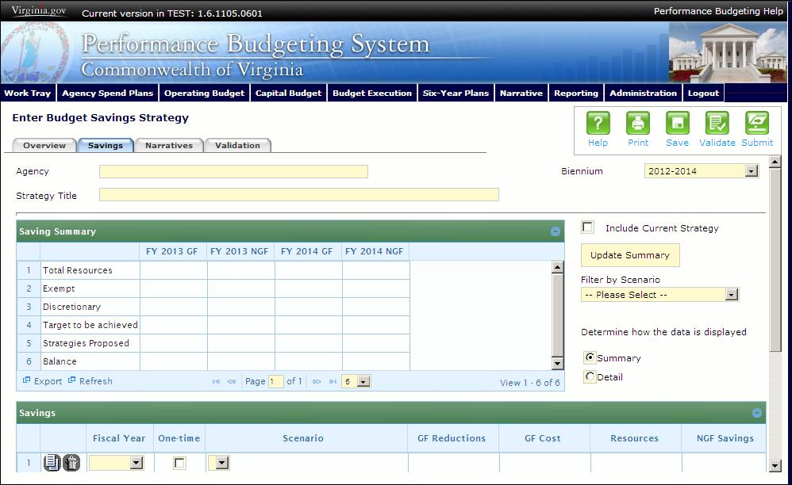
Savings Tab Instructions
- Select the Savings tab.
- Select the Filter by Scenario dropdown and select a scenario to only view information pertaining to a specific scenario.
- In the Savings Summary grid, review the predetermined budget savings targets, for the selected agency. To include the current strategy in the Savings Summary grid, select the Include Current Strategy check box and click the Update Summary button when finished entering savings details.
  - Appropriation Base. The total appropriation for the selected agency (usually legislative appropriation).
  - Exempt. The total predetermined dollars exempt from budget savings for the selected agency.
  - Discretionary. The total discretionary spending for the selected agency (equals to the Appropriation Base, less the Exempt amount).
  - Targets to be achieved. The predetermined target budget savings for the selected agency.
  - Strategies. The total budget savings for the selected agency based upon the total of the current strategies entered into the PB System.
  - Balance. The difference between the targets to be achieved and the strategies.
- Determine how the data is displayed for the strategy scenario by selecting the Summary or Detail radio button. NOTE: YOU SHOULD SELECT THE “DETAIL” OPTION FOR THE FALL 2013 REDUCTION PLAN
Detail (USE THIS OPTION)
  - In the Savings grid, select the Fiscal Year. Select the Program, Fund and/or Subobject for the strategy scenario.
  - Check the One-Time check box if the savings is one-time rather than ongoing.
  - Select the Scenario for which the strategy scenario will be applied.
  - Enter the Savings, Cost, Positions and Layoffs associated with the implementation of the strategy scenario. All numbers should be entered as absolute values except for positions.
- Savings (GF and NGF) should be entered as a positive number.
- Costs could include, for example, WTA separation costs or any new equipment needed to generate the savings.
- Layoffs are the number of classified employees or faculty that will actually be terminated. Do not include wage or contract employees in this total. This should be a whole number.
- Positions should be carried to two decimal places. If elimination of a position will result in a layoff, the layoff would be included as a layoff. If the strategy is reducing the number of positions, the number should be entered as a negative. If the strategy increases the number of positions, the number should be entered as a positive.

Summary (DO NOT USE THIS OPTION-USE THE “DETAIL” OPTION INSTEAD)
  - In the select the Fiscal Year for the strategy scenario. Check the One-Time checkbox if the savings is one-time rather than ongoing. Consult any policy guidance with respect to one-time savings strategies.
  - Select the Scenario for which the strategy scenario will be applied.
  - Enter the GF Savings, GF Cost, Resources, NGF Savings, NGF Cost, GF Positions, NGF Positions and Layoffs associated with the implementation of the strategy scenario. All numbers should be entered as absolute values except for positions.
- Savings (GF and NGF) should be entered as a positive number.
- GF Costs could include, for example, WTA separation costs or any new equipment needed to generate the savings.
- NGF costs include any increased nongeneral fund appropriations when general fund dollars are being supplanted with nongeneral funds.
- Resources are anything that generates general fund revenue. Examples include: nongeneral fund balances, new fees, capital project balances, etc.
- Layoffs are the number of classified employees or faculty that will actually be terminated. Do not include wage or contract employees in this total. This should be a whole number.
- Positions should be carried to two decimal places. If elimination of a position will result in a layoff, the layoff would be included as a layoff. If the strategy is reducing the number of positions, the number should be entered as a negative. If the strategy increases the number of positions, the number should be entered as a positive.
- Add rows to the grid as needed by clicking the Add button to specify the strategy for multiple scenarios.

Narratives Tab

Narratives Tab Overview
The purpose of the Narratives tab is to capture the description for the budget savings strategy by scenario.
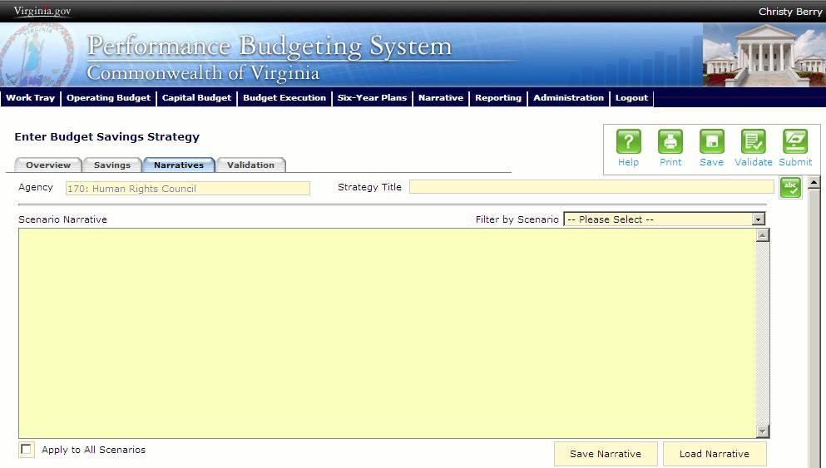
Narratives Tab Instructions
- Select the Narratives tab.
- Using the Filter by Scenario dropdown, select a scenario to enter the Description for that scenario.
Include a general description of the savings strategy, which is as specific as possible. In addition, if there are any up-front costs, please include a brief rationale. You must specify what impact each strategy has on clients/citizens/service levels, including, where possible, the number impacted. If this strategy cuts across scenarios, and the dollar savings is different, make sure to fully explain this difference.
- If there are multiple scenarios, enter a description for each scenario. There is a check box available to apply the same narrative to all three scenarios.

Budget Savings Bulk Submit Instructions
Performance Budgeting System
Bulk Submit Overview
The purpose of the Budget Savings Bulk Submit to DPB module is to allow an agency to submit all of their Budget Savings Strategy work items to DPB at once.
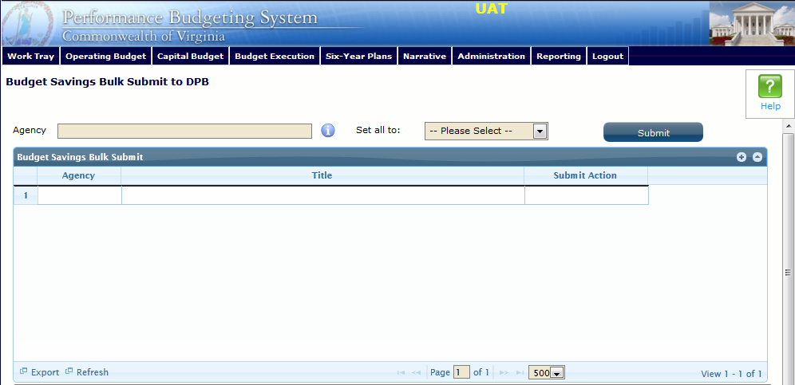
Bulk Submit Instructions
- To ensure that all savings strategies are accounted for, look at the Title column.
- To bulk manage the submit action, click the Set all to dropdown and select the submit action that the requests require: Submit to DPB, Continue Review, or Return to Previous Submitter. If submitting to DPB, all requests must be set to Submit to DPB.
- Click the Submit button. A message will display in the text box below the submit button to alert you that the submission was successful. If you receive a message that one or more work items could not be submitted, you should navigate to the work tray and open the work items to determine if they are failing validation rules for some reason.

